* **TASK- 2**
* **IT in Automobiles**

***The automobile industry is undergoing a major transformation with the integration of IT, AI, and semiconductor-based embedded systems. Modern vehicles are equipped with Electronic Control Units (ECUs) that manage everything from engine performance to driver assistance features. Advanced Driver Assistance Systems (ADAS), powered by real-time data processing and machine learning, enable features like lane-keeping assistance, adaptive cruise control, and automatic emergency braking. Semiconductors play a key role in electric vehicle (EV) battery management, autonomous driving technologies, and Vehicle-to-Everything (V2X) communication, which allows cars to interact with infrastructure, pedestrians, and other vehicles. The integration of IoT and 5G connectivity has also enabled over-the-air (OTA) software updates, ensuring vehicles remain up to date with the latest software and security patches.***

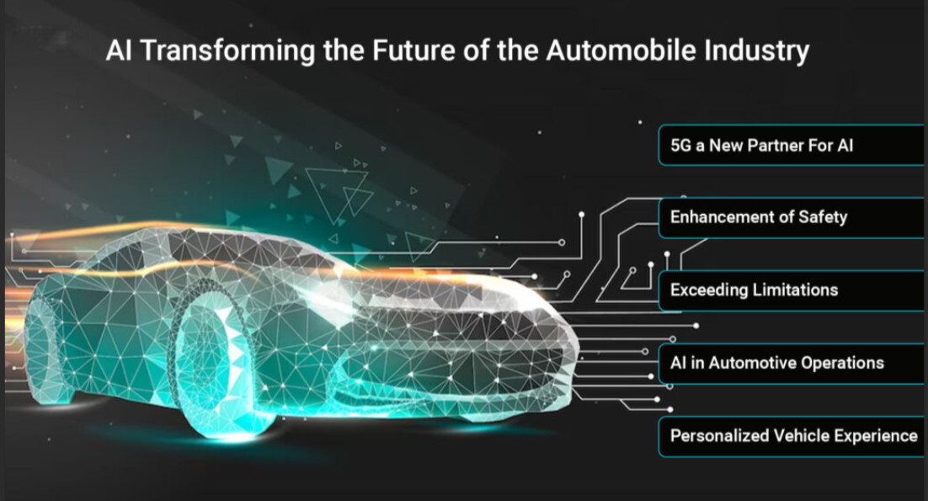

* **IT in Metro Rail**

***The metro rail sector relies on semiconductor-based embedded systems for automation, real-time monitoring, and safety. Automatic Train Control (ATC) and Communication-Based Train Control (CBTC) systems ensure efficient train operations by optimizing speed, signaling, and track switching. Smart ticketing systems, using RFID, NFC, and biometric authentication, enable contactless entry and seamless passenger flow. Metro networks also use IoT-based sensors for predictive maintenance, ensuring early fault detection in tracks, rolling stock, and electrical components. SCADA (Supervisory Control and Data Acquisition) systems manage power distribution and ventilation within tunnels, ensuring a smooth and safe ride. The adoption of AI-driven traffic management systems further optimizes train frequency, reducing congestion and improving energy efficiency.***



* **IT in Avionics**

***Aviation depends heavily on high-performance computing, semiconductor-based avionics systems, and AI-powered automation. Flight management systems (FMS) rely on advanced microprocessors for navigation, autopilot functions, and fuel optimization. Real-time avionics software enables precise GPS based navigation, allowing aircraft to follow optimal flight paths while reducing fuel consumption. Semiconductors power radar systems, collision avoidance technology, and in-flight connectivity, ensuring both passenger safety and enhanced travel experience. Ground operations benefit from air traffic management software, baggage tracking systems, and AI powered predictive maintenance. The latest advancements include More Electric Aircraft (MEA), which replace traditional hydraulic systems with semiconductor-based electric actuators, reducing weight and improving fuel efficiency.***

